PHYS1110D – Engineering Physics: Mechanics and Thermodynamics

Week 7: Common Confusions in Assignment 4

**Problem 3**

The problem describes the following scenario:

*“An object of mass 30 g suspended from a spring elongates the spring 4 cm beyond its natural length.”*

In the following, we use the word “system” to refer to the object and the spring as a whole.

Many students thought that during this process, the energy of the system is conserved, and used this to find the stiffness of the spring ($x_{0}=4 \text{cm}$):

$$\frac{1}{2}kx_{0}^{2}=mgx_{0}⟹k=\frac{2mg}{x_{0}} \left(\text{wrong}\right)$$

However, this is *not* the case. The correct $k$ is simply given by the equilibrium condition

$$kx_{0}=mg⟹k=\frac{mg}{x_{0}}$$

Then why is the energy of the system not conserved?

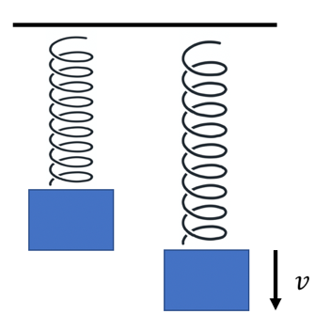To understand this mystery, we need to think how *in reality* this process can happen. At first, the object will fall because of the gravity. But here comes a vital observation: when the object passes through the point at which the gravity balances out the force of the spring, the object *must have a nonzero velocity*. During all this process, the energy is of course conserved. Then, in order to *stop* the object, we must apply an *external force*, which causes the mechanical energy of the object-spring system to change. It is *impossible* for the system to *spontaneously* reach this final state.

*Remark: This problem tells us that we must think how a process described in the questions can be actually achieved. If it is not possible at all, we cannot apply any physical laws to it, or we will get results that has no physical meaning.*

In addition, we want to teach you a *geometric* way of judging whether the energy of the system is changed. Suppose we choose the origin of the coordinates at the free end of the spring, and the downward displacement of the object is denoted by $x$. Then the conservation of energy gives the equation ( $p=mv$ as usual)

$$\frac{p^{2}}{2m}+\frac{1}{2}kx^{2}-mgx=E \left(\text{const}\right)$$

(In our problem the constant is simply zero. Can you see why?) This represents an *ellipse* in the $xp$-plane (called the **phase space** by physicists, see the figure. Each point on this plane is called a **state** of the system). *The energy is larger outside the ellipse, and smaller inside it.* Just like the general case: an equation (constraint) reduce the set of allowed values of the coordinated from the whole plane to a single curve. Comparing with the standard formula

$$\frac{{(x-x_{0})}^{2}}{a^{2}}+\frac{{\left(p-p_{0}\right)}^{2}}{b^{2}}=1$$

We see that the center of ellipse is located at

$$x_{0}=\frac{mg}{k}, p_{0}=0$$

However, we recognize this point as the *final state* of the system! (the object is at the position where $kx=mg$, and has no velocity ($p=0$)) The center of an ellipse is definitely *in* the ellipse, thus the final state must have a *smaller energy* from the initial state (which is *on* the ellipse).

*Note: The phase space has a more exciting application when the equation of motion cannot be solved analytically. It is beautifully explained in this video by 3Blue1Brown (*[*https://youtu.be/p_di4Zn4wz4*](https://youtu.be/p_di4Zn4wz4)*). Besides, you can also see the supplementary material of this week’s tutorial to learn how to describe the motion of the block if air resistance is present.*